1. Define random variate. Elaborate different techniques to generate random variates.
2. Provide definitions of the following:
   1. Geometric distribution
   2. Poisson process
   3. Calling population
   4. List processing'
3. Define Markov chains also identify the common Markov models.
4. Explore Petri net its uses and its initiative structures.
5. Consider single server, infinite queue length and infinite population queueing model where arrival and service of entities both follow the Markovian property. Model the system at steady state and derive expression for expected number of entities is the system.

**Explain stochastic processes and its classification.**

Stochastic processes are mathematical models used to describe systems that change randomly over time. They are used in various fields such as finance, physics, engineering, etc. for modeling and simulation purposes.

Classification of Stochastic Processes:

* Discrete-time and continuous-time processes
* Stationary and non-stationary processes
* Markov processes and non-Markov processes
* Gaussian processes and non-Gaussian processes

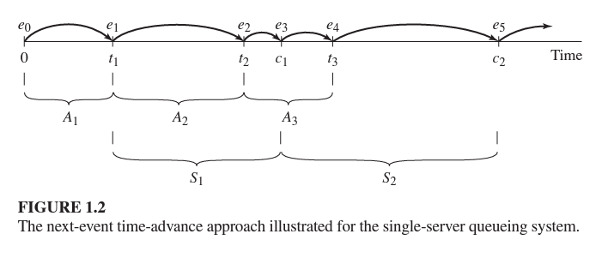

**Classify characteristics of queuing systems**

The key elements of queuing systems are customers and servers.

* The term customer can refer to people, machines, trucks, airplanes etc. Anything that arrive at a facility and requires service.
* The term server can refer to receptionist, repair personnel, runways in airport, washing machines etc. Any resource that provides the requested service.

Below we describe the elements of queuing systems in more details.

**Arrival Pattern:** The arrival process for infinite population models is usually characterized in terms of inter-arrival times of successive customers.

**Service Pattern:** It measures service rate and can be stochastic or deterministic.

**Queue Discipline:** Queue discipline refers to the logical ordering of customers in a queue and determines which customer will be chosen for service when a server becomes free. Common queue disciplines include first-in-first-out (FIFO), last-in-first-out (LIFO), service in random order (SIRO) etc.

**No of Service Channels:** Parallel queue example

**No of Service Stages:** The more services the more it is complete.

**Calling Population:** The population of potential customers, referred to as the calling population.

**System Capacity:** In many queuing systems there is a limit to the number of customers that may be in the waiting line or system.

**Classify the system w.r.t interaction.**

**Independent-** If the events have no effect upon one another, then system is classified as independent.

**Cascaded-** If the effects of the events are unilateral (that is, part A affects part B, B affects C, C affects D, and not vice versa), the system is classified as cascaded.

**Coupled-** If the events mutually affect each other, the system is classified as coupled.

**Components and Organization of a Discrete-Event Simulation Model**

**System state:** The collection of state variables necessary to describe the system at a particular time .

**Simulation clock:** A variable giving the current value of simulated time.

**Event list:** A list containing the next time when each type of event will occur.

**Statistical counters:** Variables used for storing statistical information about system performance.

**Initialization routine:** A subprogram to initialize the simulation model at time 0.

**Timing routine:** A subprogram that determines the next event from the event list and then advances the simulation clock to the time when that event is to occur.

**Event routine:** A subprogram that updates the system state when a particular type of event occurs (there is one event routine for each event type)

**Library routines:** A set of subprograms used to generate random observations from probability distributions that were determined as part of the simulation model.

**Report generator:** A subprogram that computes estimates (from the statistical counters) of the desired measures of performance and produces a report when the simulation ends.

**Main program:** A subprogram that invokes the timing routine to determine the next event and then transfers control to the corresponding event routine to update the system state appropriately. The main program may also check for termination and invoke the report generator when the simulation is over.

**Explain the steps of simulation study also depict through diagram.**



**Techniques to perform Verification of Simulation Model**

* Use good programming practice
* Use structured walkthroughs
* Use a trace
* Check simulation output for reasonableness
* Animate
* Compare final simulation output with analytical results

**Techniques for Validation of Simulation Model**

3 Step Approach

**1. Build model that has high face validity.**

* Ensure high degree of realism.
* The model must be discussed with system experts while designing.
* The modeler must interact with client throughout the process.
* The output must be supervised by system experts.
* Sensitive analysis can also be used to check model’s face validity**.**

**2. Validation of Model Assumptions**

* **Structural assumptions** involve questions of how the system operates and usually involve simplifications and abstractions of reality
* **Data assumptions** should be based on the collection of reliable data and correct statistical analysis of the data

**3. Validating input output Transformations**

* Determine how close is the simulation output with real system output
* Statistical models can be used to compare model output with real system output
* Validating Existing System
* Validating First Time Model
* Subsystem Validity
* Internal Validity
* Sensitivity Analysis
* Face Validity

**List the steps of input modelling, give pitfalls of data collection how these pitfalls can be handled.**

1. Collect data from the real system of interest
2. Identify a probability distribution to represent the input process
3. Choose parameters that determine a specific instance of the distribution family
4. Evaluate the chosen distribution and the associated parameters for goodness of fit

Data Collection

* Data collection is one of the biggest tasks in solving a real problem
* It is one of the most important and difficult problems in simulation
* And even when data are available, they have rarely been recorded in a form that is directly useful for simulation input modeling

**Pitfalls**

* Stale Data
* Unexpected Data
* Time Varying Data
* Dependent Data